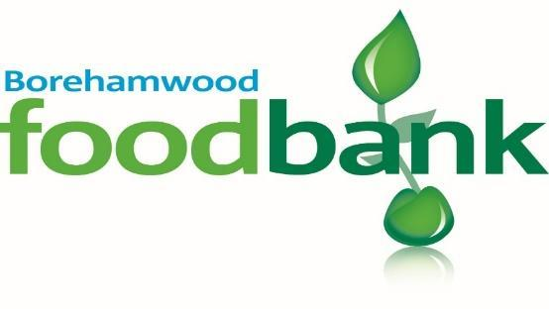

**Summer**

**Food & Fun**

**Wednesdays**

**July 22nd & 29th August 5th, 12th, 19th & 26th**

**11am - 1pm**

St Teresa’s Church Hall, 291 Shenley Rd.

Activity Packs, Cooking Packs & Treats

Due to social distancing we require you to park in the council pay and display car park, we will reimburse this cost.

No Booking Necessary

**Please note this is a free family event for those with children.**

**Sponsored by Caritas.**