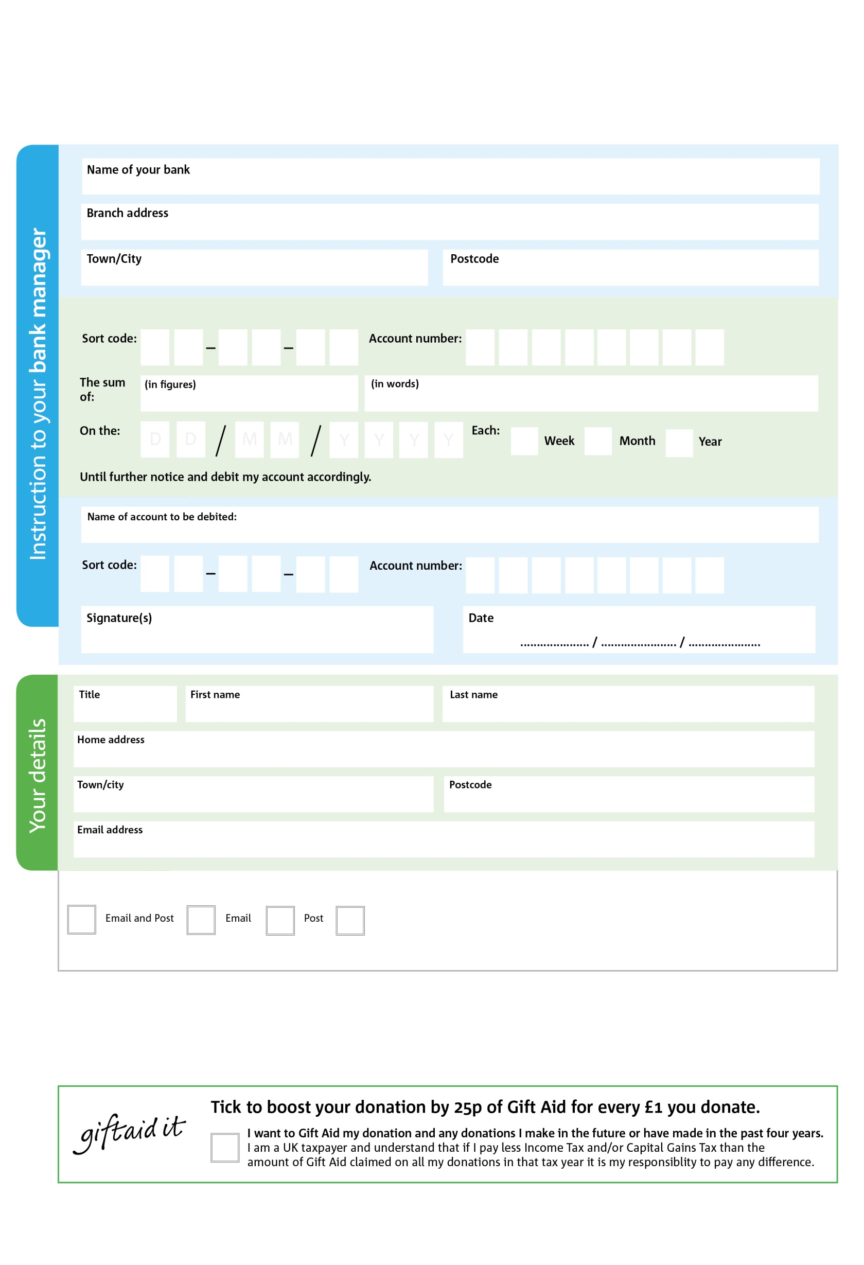

7

1X

Reg. Charity No: 1155599 | Reg. in England & Wales

POSTAL ADDRESS: Borehamwood Foodbank, 291 Shenley Road, Borehamwood, Herts WD6 1TG

I do not wish to receive future communications from Borehamwood Foodbank

**Data protection**

*'Borehamwood Foodbank is committed to protecting your privacy and will process your personal data in accordance with current Data Protection legislation. Borehamwood Foodbank collects information to keep in touch with you and supply you with information relating to our work. To unsubscribe from our newsletter, send a message to the email address above with the word unsubscribe in the subject line. A full data privacy statement for financial donors is available from the foodbank on request.’*

You can change your preferences any time by contacting us on 0203 583 1109 or emailing us at info@borehamwood.foodbank.org.uk

You can change your preferences any time by contacting us on XXXXXXXXXXX or emailing us at XXXX@XXXXXXXXXX.foodbank.org.uk

8X

V

1X

V

5X

V

5X

V

4X

V

5X

V

1X

V

9X

V

Please pay Borehamwood Foodbank,

2X

2X

4X

0X

**Please pass this form onto the foodbank, using the foodbank’s address at the bottom, who will save a copy for their records.   
They will then send it onto your named bank or building society.**

We would love to keep you up to date with information about Borehamwood Foodbank. Please tick your preference:

**Standing Order Mandate**

**borehamwood.foodbank.org.uk**

I do not wish to receive future communications from XXXXXX Foodbank